Specific case descriptions

In this paper, the research comes from a real case (the case is anonymised), a global large-scale Internet enterprise (companyB) and another company responsible for demand analysis work together to develop a professional big data platform project for companyA. The company responsible for demand analysis needs to complete the collection of demand, analysis, data cleaning and annotation. The software development company is responsible for the project's front-end and back-end code writing, user profile analysis, personalised recommendations and other new AI technologies. The two parties complete their respective tasks and finally deliver the software to the client side. As the project advances, there are deviations in communication, organisational structure and so on between the two companies, which ultimately leads to the development of the project in an unanticipated direction, making the project cost and time seriously overrun.

Through this failed collaboration, companyB expects to be able to quantify the complexity of the project process and the flaws in the organisational structure, so that in the future, the organisational structure and complexity can be analysed at the beginning of the project in order to reduce the risk of project failure.

Based on the above case, we used the problem framing approach to model the case. The figure below shows the entire problem framing modelling diagram, where the red solid line indicates abnormal communication, the red dotted line indicates lack of communication, the blue solid line indicates correct communication, the dotted lines connecting the domains indicate containment relationships, and the dashed ovals indicate requirements/tasks. Our management structure zoom-in only goes down to the group level, where the person in charge within the group communicates on behalf of the group, and does not care about the individual level within the group (which can lead to overly redundant information). After zoom-in you can see the details of communication between departments, assignment of tasks, etc.

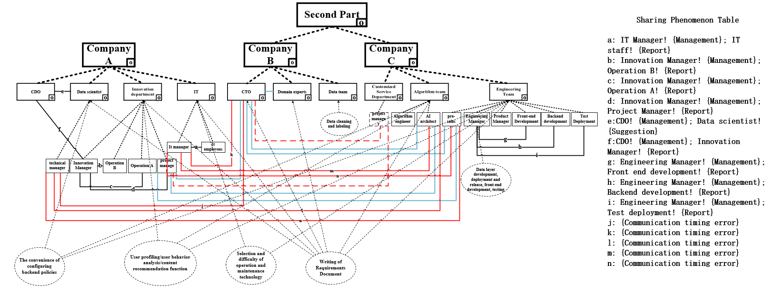

In this case, Party A's data scientist team, innovation department, and IT department proposed several different requirements at the same time during the requirements analysis phase, resulting in Party B1 being unable to confirm the requirements, and ideally (as in Figure 6), the project manager of Party B1, who should have conducted the requirements analysis work with the project manager of Party A's innovation department and the CTO of Party B2, ended up with Party B1's AI architect conducting the Requirements analysis work. This ultimately led to serious delays in the project cycle, resulting in huge labour costs. The red dotted line in the above figure indicates the communication gap of the project manager of Party B1. The red solid line indicates the communication anomaly that arose between Party A's internal data scientist team, innovation department and IT department, Party B1 algorithm team and engineering team, and Party B2 CTO due to the timing error in requirements communication. Because according to the standard, the innovation department focuses on the main business such as user behaviour analysis/content recommendation, and needs to solve the business requirements first, while the data scientist team focuses on the convenience of back-end strategy configuration, and the IT department focuses on the difficulty of operation and maintenance, and other technical issues, which should be the secondary requirements, and then carry out the requirement analysis.

The two types of zoom-in provided by the problem framework focus on different dimensions. The zoom-in on the management structure described above facilitates the overall control and complexity calculation of the project, whereas the analysis of specific tasks at a more granular individual level can be accomplished through the task-driven zoom-in (as shown in Figure below). The task-driven zoom-in reduces visual complexity, and through the fine-grained portrayal of a specific task, it intuitively understands the defects that occur in that requirement task. The zoom-in graph starts with the task and ends with the completion of the task to form a path, and the nodes on this path are the people involved in the task, which belong to the department.

